ABSTRACT:
creating a database for animal species with limited options finding the animal species with their featues and displaying their database.

RELATIONAL MODEL:
animals (animal_id PK, animal_name, animal_species, animal_habitat)
symptoms (symptom_id PK, symptom_name, symptom_description)
animal_symptoms (animal_id FK, symptom_id FK, PRIMARY KEY (animal_id, symptom_id))

ER DIAGRAM:

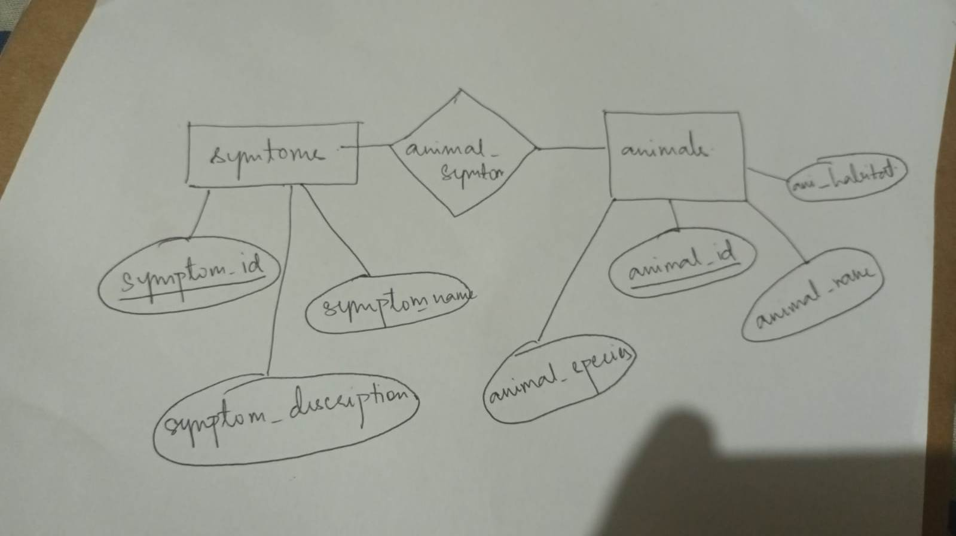

SQL QUERIES:

CREATE TABLE animals (
animal_id INT PRIMARY KEY,
animal_name VARCHAR(50),
animal_species VARCHAR(50),
animal_habitat VARCHAR(50)
);

INSERT INTO animals (animal_id, animal_name, animal_species, animal_habitat)
VALUES
(1, 'African Elephant', 'Loxodonta africana', 'Savanna'),
(2, 'Giant Panda', 'Ailuropoda melanoleuca', 'Bamboo forest'),
(3, 'Bald Eagle', 'Haliaeetus leucocephalus', 'Forests and wetlands'),
(4, 'Blue Whale', 'Balaenoptera musculus', 'Open ocean');

CREATE TABLE symptoms (
symptom_id INT PRIMARY KEY,
symptom_name VARCHAR(50),
symptom_description VARCHAR(255)
);

INSERT INTO symptoms (symptom_id, symptom_name, symptom_description)
VALUES
(1, 'Fever', 'An increase in body temperature'),
(2, 'Coughing', 'A sudden expulsion of air from the lungs'),
(3, 'Sneezing', 'A sudden, forceful expulsion of air through the nose and mouth'),
(4, 'Lethargy', 'A lack of energy or enthusiasm');

CREATE TABLE animal_symptoms (
animal_id INT,
symptom_id INT,
PRIMARY KEY (animal_id, symptom_id),
FOREIGN KEY (animal_id) REFERENCES animals (animal_id),
FOREIGN KEY (symptom_id) REFERENCES symptoms (symptom_id)
);

INSERT INTO animal_symptoms (animal_id, symptom_id)
VALUES
(1, 1),
(1, 4),
(2, 2),
(2, 4),
(3, 2),
(4, 1),
(4, 2),
(4, 3);

